Lesson Plan - Running the pair reading

Standard: SS.7.C.3.10 Identify sources and types (civil, criminal, constitutional, military) of law.

Students will know | Students will be able to
The Types of Laws  - Compare statutory and common law as sources of types of law  - It is important for students to see a lot of different scenarios to practice comparing different sources of law  - Students are going to need to understand the concept of “precedent” to understand common law. | - Compare statutory law and common law.  - Analyze scenarios to determine the source and of law

Time: 30-45 minutes

Supplies needed: Chromebook or personal device for Google Docs version.
Printouts - 1 reading packet per group. (A and B documents for pairs)

Instructions:

Inform students that they will be working on a pair reading activity and will be working with a partner. I like to remind students to think carefully about who they want to work with to help them accomplish the goals of the assignment.

Have students pair up. You may allow them to select their own pair, assign pairs randomly, or any way you please (placing stronger readers with weaker readers). I have also included a reading/worksheet for a single student, should they not wish to work with a partner or missed portions of your class where they paired up together. This works ideally with partners but if you wish to put them in groups of three or four, that can be accomplished as well.

Different reads - A and B have information the other doesn’t
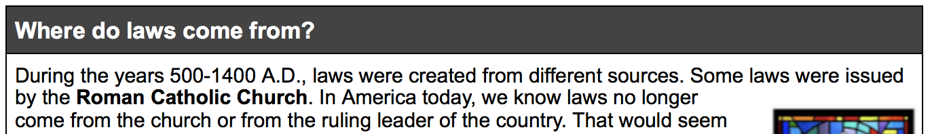
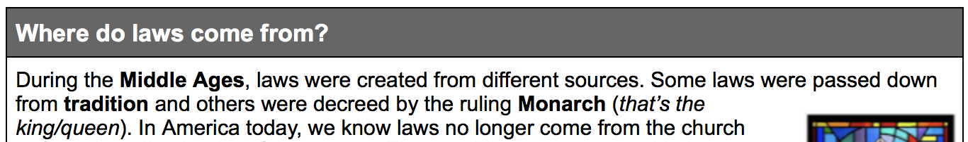

Have A or B read through the first line of the reading. While one reads aloud, the other reads along silently, listening and looking for any differences. If any differences are spotted, the listener should speak up and compare differences. For example, If partner A begins reading aloud, Partner B should mention after the first sentence something about the Middle Ages. Using their combined information, they should be able to put together that the Middle Ages occurred between the years 500 A.D. to 1400 A.D. If not, the questions asked of them at the end of the section will focus them on the differences of information and create communication between students. Observe:

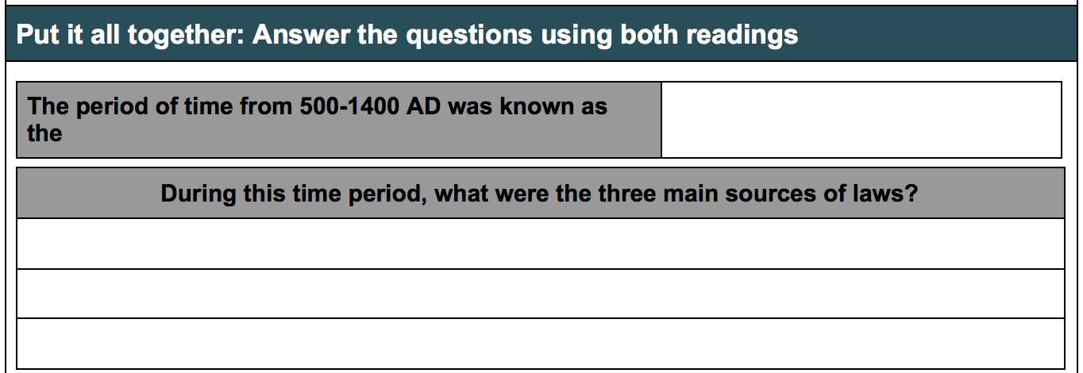

I’ve also added in some information that has nothing to do with the standard and everything to do with building communication and interaction between partners.
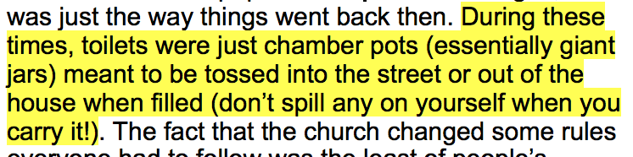
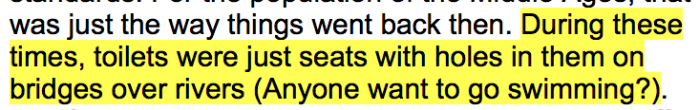

To drive the point home even further, I make them give their subjective opinion on the matter.

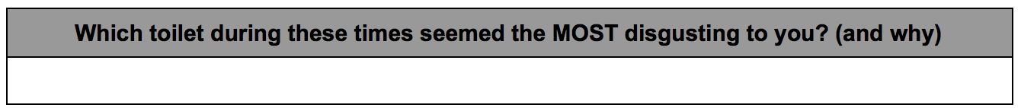
You may, of course, omit these portions if you feel it will derail certain classes or groups of students. I personally enjoy reading these answers the most while grading papers. You might even be asked to put up a chamber pot on screen to display for the class!

Alternatives to reading in turn

Another way you can run this activity is to have each pair read their paragraph silently to themselves and then try to ‘splain it to their partner afterwards. They should pick up on some major differences in the information and further discuss and compare. This works well with some classes that have trouble speaking and reading in turns but can become a little bit louder and more chaotic.

A timer works well for this method, allowing enough time for each partner to read and comprehend their passage yet also making sure they are moving at a pace fast enough to complete the assignment.
----------------------------------------------------------------------------------------------------------------------------

One other alternative you can try is to group up all the A’s together and B’s together and have them read their half of the document in large groups. After each group has read the section and discussed it in their large group, they’ll need to get up and find someone from the other group to complete the questions. The A’s should have a strong grasp of their information and may be able to answer part of the questions for the section but will need to partner up with a B in order to completely answer all questions.

Wrapping up the assignment - Formative Assessment

Using call and response, marker boards, or creating a quick google form, you can ask a series of questions comparing Statutory and Common Laws. Students should also be able to analyze scenarios of Statutory and Common Laws and be able to identify the source of law.

QUESTIONS:

Which law is created by lawmakers? Statutory

Which law is created by elected officials in government? Statutory

Which law is created by past rulings? Common

Which law involves precedent? Common

A judge considers a past ruling of a similar case to issue a punishment to a convicted felon. Which source of law is this? Common

A law has been discussed, debated, and voted on by lawmakers. It is awaiting the signature of the President. Which source of law is this? Statutory

